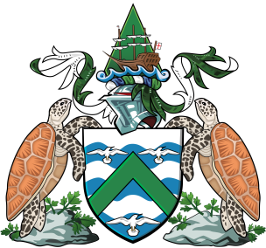

Ascension Island Government

VACANCY NOTICE

We are currently looking to fill the following vacancies to deliver essential work within our Operations & Facilities teams:

Refrigeration Mechanic (Accompanied Status) | £11,610
Construction Operative – Mason (Single Status) | £11,092
Construction Operative – Painter and Glazier (Single Status) | £9,540

Full job descriptions can be obtained by emailing recruitment@ascension.gov.ac or telephone 00247-67000 x150

All roles are offered as 2-year fixed-term contracts, with the following benefits:

- Rent free accommodation
- A Single status food allowance of £3,350 per annum or Accompanied Status of £6,700
- Travel to and from Ascension at the start and end of the contract
- Relocation costs for your personal effects, including the shipment of a vehicle
- One mid-contract return journey to your country of recruitment
- A gratuity payable on the successful completion of a 2 year contract
- 30 days’ annual holiday (with additional 9 days public holidays)
- Free primary dental and medical care
All appointments will be subject to:
- Satisfactory employment references
- Criminal Records Check
- Satisfactory Medical Clearance

Closing Date: Monday 10 May 2021
Interviews: tbc (by Skype if off island)

To apply, send your CV to recruitment@ascension.gov.ac or deliver to the HR Office, AIG Administration Building, Georgetown.

For more information, visit: https://www.ascension.gov.ac/lifestyle-and-employment/working-here/

